TerraTreks Dolomites Itinerary —June 16 to June 24, 2023
Powered by Walk the World, LLC
The UNESCO World Heritage Dolomites are comprised of 9 mountain systems linked together by common features referred to as the Dolomitic Landscape. Ask anyone who has hiked in this area and you are likely to hear it is the most beautiful place they have ever been. The fundamental characteristic of the Dolomites is the striking contrast between the sheer vertical lines of the enormous rock formations and the gentle, rolling contours of the meadows. The Dolomite range is the only area in the world where pale dolomite and dark volcaniclastic rocks are found together. This combination creates a natural visual phenomenon known as Enrosadira where the colors of the rock faces react dramatically to changes in light. The Dolomites are also rich in World War I history. The route we follow takes us through some of the most geologically interesting areas of the dramatically beautiful Dolomites as well as WWI historical sites.

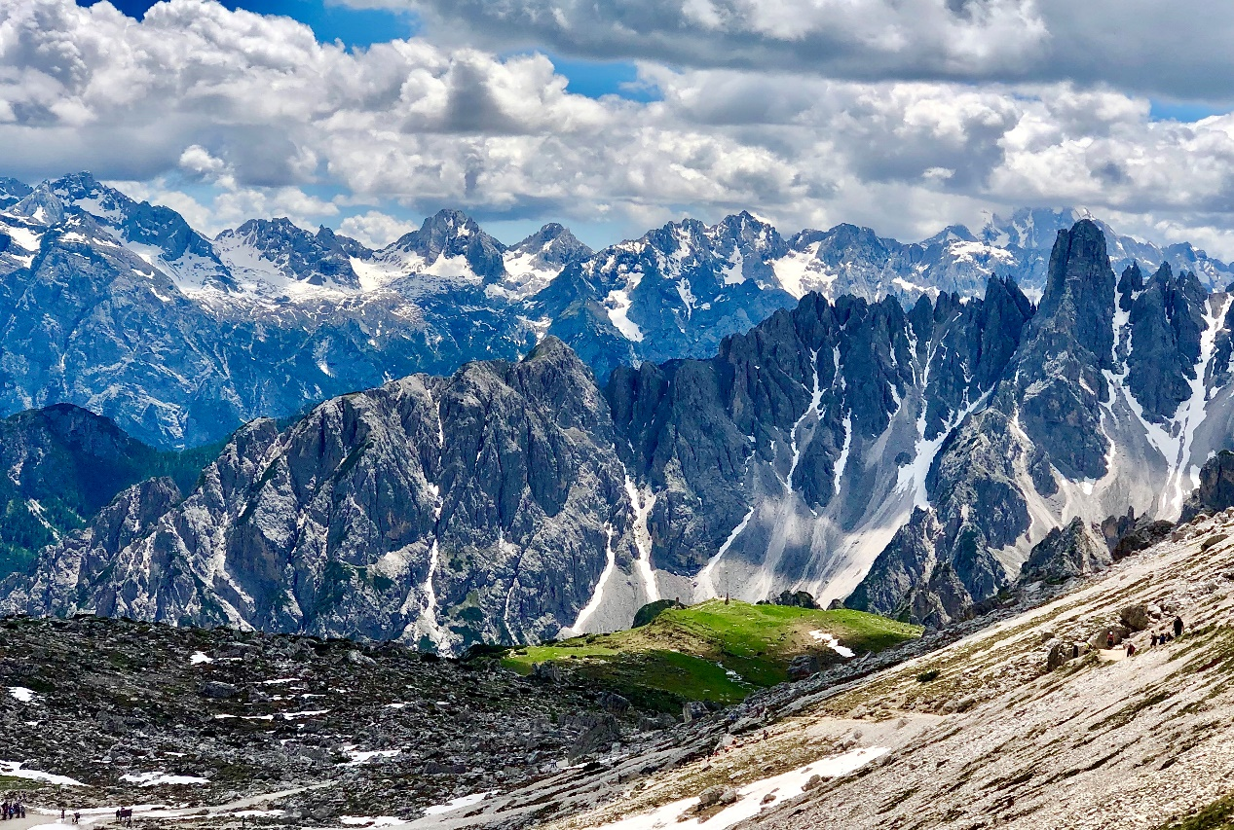

The path begins along Lake Braies in the Puster Valley in the Northern Dolomites and leads through the Belluneser Dolomites into the Ampezzaner Dolomites to Cortina d’Ampezzo and the Tre Cime/ Drei Zinnen. The first section of the Dolomites Mountain trail leads from Lake Braies to Passo Giau. The main route is at an average altitude of 2100 meters (6700 feet). The highest summit we cross is Heiligkreuzkofel at 2907 m (9537 ft) on the fourth day. Our highest overnight stay, at Refugio Lagazuoi, is at an elevation of 2752 m (9028 ft) and occurs on night five; by days four and five you should easily adjust to these higher elevations.
Except for two days, luggage is transferred to our hotel or refugio for the night, so we carry only a light day pack. We will meet in Venice and transportation to Lake Braies, our starting point for the hike, is included as well. We stay four nights in family-owned local inns and hotels, and four nights in historic mountain refugios. The trip includes rental gear (snow spikes in case of snow patches and a helmet for the descent through the tunnel on day 6) eight breakfasts, three lunches and five dinners, including a farewell dinner on the last evening. The remaining lunches and dinners may be purchased at the huts and hotels. This option provides everyone with the opportunity to order their favorite dishes and sample the local cuisine as desired. The huts we visit are known for excellent cuisine as are the lodges and hotels we have chosen.
This hike requires good physical condition, mountain experience, and above average fitness levels. Anyone with hiking experience in the Sierra Nevada, Rocky Mountain, or similar ranges should be able to tackle this hike.

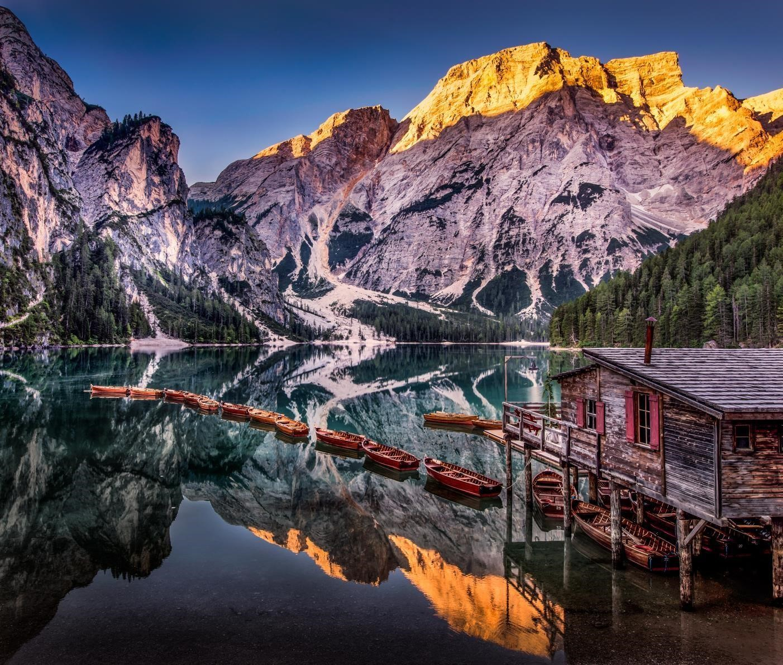
Lago di Braies
Photo Courtesy of Robert Schmalle Photography

Day 1 – Friday, June 16
Meeting point: Venice, Italy at 1:00pm. We will meet at Parcheggio NCC Piazzale Roma located at Rio Terà Sant' Andrea, 460, 30135 Venezia, Italy, for transport to Hotel Pragser Wildsee in the Puster Valley. (Note: It sounds beautiful in Italian, but Parcheggio is a Car Park accessible by water taxi from Venice. It is a convenient location for the van to meet us and the closest facility to Venice).

The hotel is a historic lodge and the only accommodations situated on the shore of Lago di Braies so in the evening we have the place to ourselves and the views are amazing. During the day, when we are away hiking, the lodge and lake are favorites of the Italians because a popular TV show is filmed there. We begin our hike in the Dolomites with a walk around the lake before dinner, be sure to bring your camera along.

https://www.lagodibraies.com/en/
Walking time approx. 1 hour, ascent 50 m (164 ft), descent 50 m, length approx. 4 km (2.5 miles)
Technical Route Category: (Easy) BBBBBB (See page 13 for a description of the categories)
Overnight: Il Tyrol Hotel, San Candido deluxe room with private bath
4 Star Hotel at San Candido - Sporthotel Tyrol

Meals: Dinner

Day 2 – Saturday, June 17
Today we day tour around the Schwarzberg (Monte Nero, 2,142 m). This beautiful round trip loop starts directly at Lake Braies and leads us via Ried (1,563 m) to the Kühwiesenalm and on to the Kühwiesengipfel (2,140 m). After a rest and photo op at the summit, the route takes us to the Pragser Kaser (1,932 m) and around the Schwarzberg (2,142 m) down to Grünwaldalm (1,590 m, refreshment stop). We return to the hotel Pragser Wildsee through the Grünwaldtal.

Walking time approx. 6 hours, ascent 800 m (2625 ft), descent 800 m, length approx. 10 km (6.2 miles). There is no opt-out to use a van or cable car on any segments of today’s hike.
Technical Route Category: (Easy) BBBBBB
Overnight: Il Tyrol Hotel, San Candido deluxe room with private bath
Meals: Breakfast and Dinner

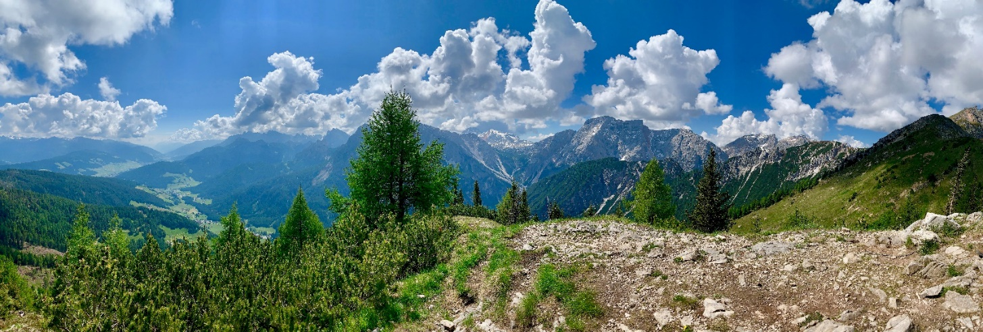

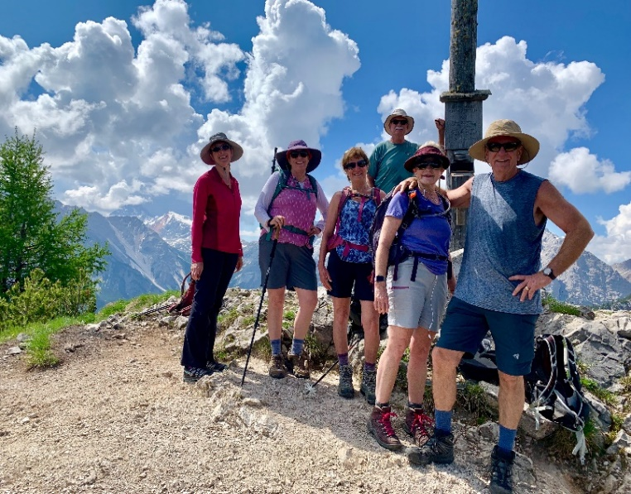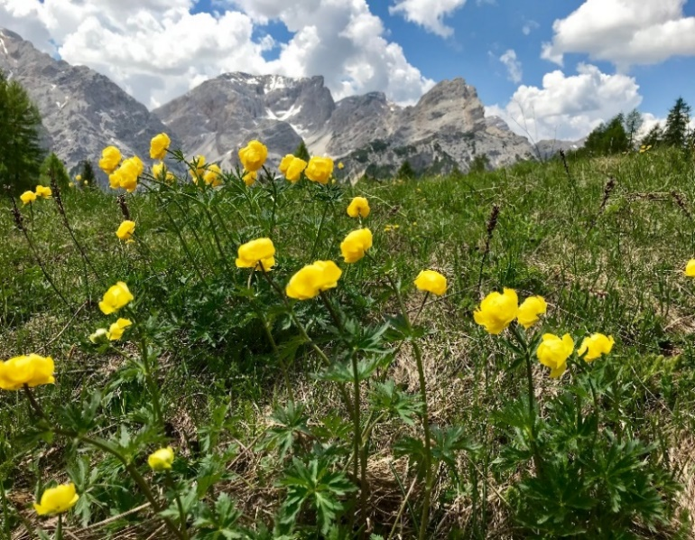
Summit at Kühwiesengipfel
Day 3 –Sunday, June 18
After breakfast we start with an easy hike along the lake before beginning the ascent to Sora al Forn-Scharte (2,388 m), where we reach the Sennes plateau. After a short descent to the Seekofel Hut (2,325 m), we continue to the cozy Sennes Hut for lunch (2,116 m). After lunch, the path leads steeply down to Pederü (1,545 m). From there we take the 4x4 taxi to the beautiful Fanes Hut (2,060 m) where our private rooms with patios will be waiting.

Walking time approx. 7 hours, ascent 950 m (3117 ft), descent 900 m (2953 ft), length approx. 14.5 km (9 miles).
Technical Route Category: (Easy) BBBBBB
Overnight: Fanes Hut—private room with private bath. http://www.rifugiofanes.com/en/dolomites-hut.htm Meals: Breakfast and dinner

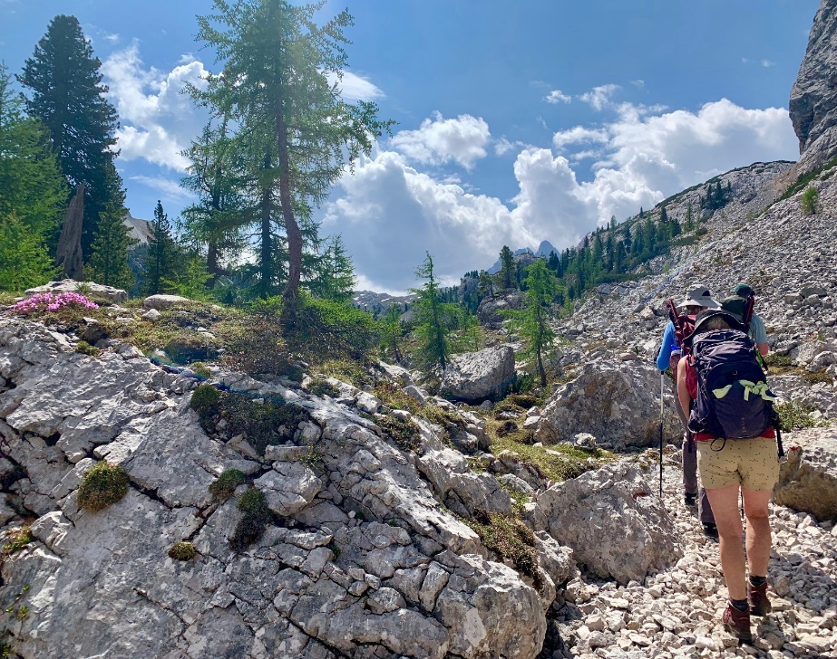
The trails on our Dolomites hike are sparsely traveled. Most days we will see only a few, if any, hikers along the way.
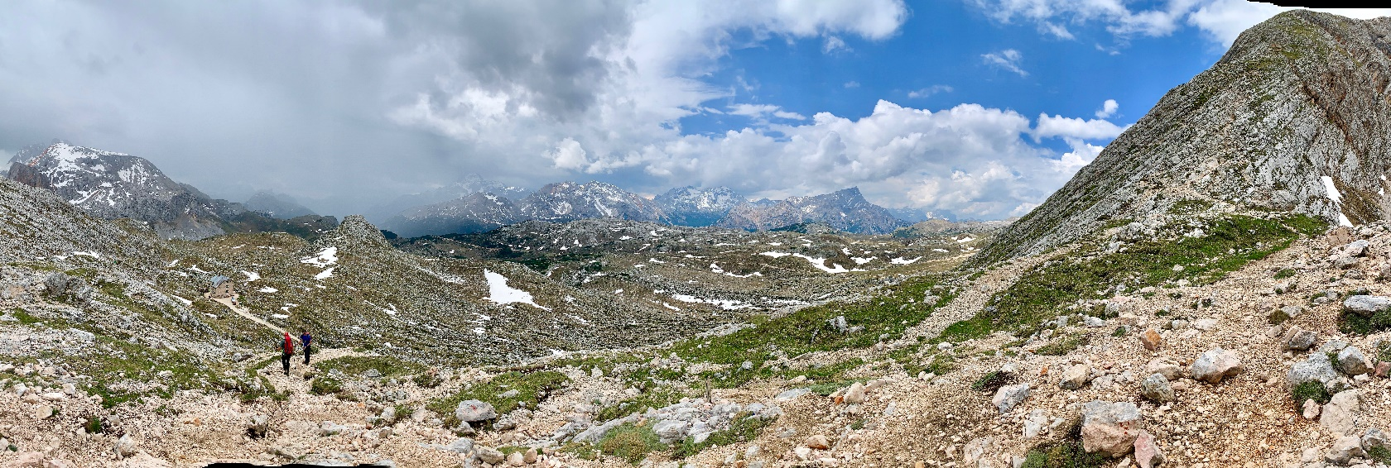
Day 4 –Monday, June 19
Day tour to the Heiligkreuzkofel (2,907 m). The Heiligkreuzkofel offers a scenic, extremely rewarding, varied, and moderately strenuous mountain hike over the Fanes Plateau. The path is narrow in spots but well-marked with no drop-offs. The view from the summit, which slopes steeply to the west, is magnificent especially the iconic Marmolada, which appears to rise from the plateau as if it were placed in the center of a platter of breathtaking landscape. The last pitch to the summit is steep and has loose rocks (scree slope). The descent follows the ascent route. Another overnight stay at the Fanes hut.

Walking time approx. 7 hours, ascent 950 m (3117 ft), descent 950 m, length approx. 15 km (9.5 miles) Technical Route Category: (Mostly Easy/Some Moderate) BBRRBB
Overnight: Fanes Hut - Private room with private bath.
Meals: Breakfast and dinner

Day 5 –Tuesday, June 20
After a short climb we soon reach the Limojoch (2,172 m) and arrive via the Fanes plateau to the Passo di Lago (2,480 m). From the top of the pass we can see Lago Lagazuoi (2,182 m) below us, where we spend our lunch break after a short but steep descent. In the afternoon we hike over the forc. Lagazuoi (2,573 m), past historic sites from WWI, to the summit of Little Lagazuoi (2,752 m). Refugio Lagazoui is set on the summit of with sensational panoramic views. The hut has a large wraparound deck and on a clear day with the sun shining through white puffy clouds it is hard to beat this location. Grab a glass of wine and enjoy!

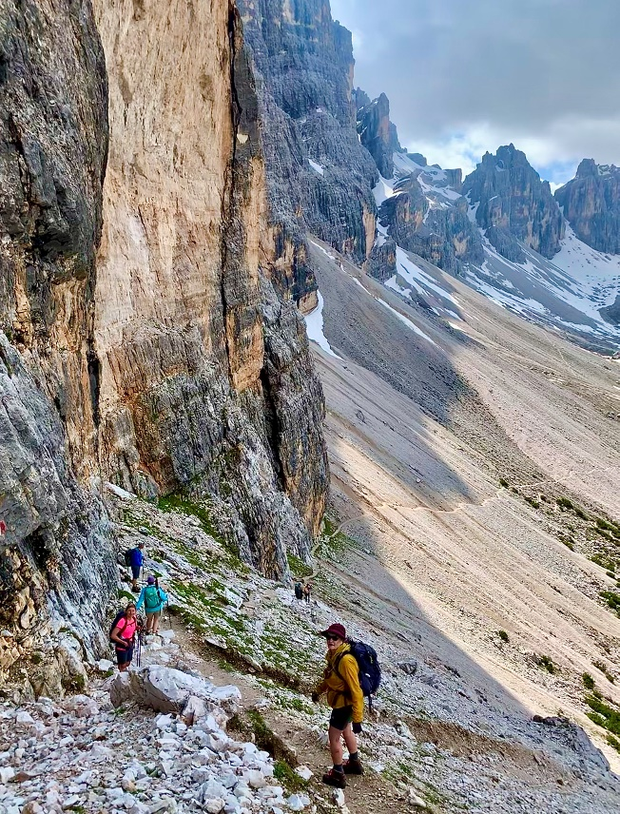
Walking time approx. 6 to 7 hours, ascent 1050 m (3445 ft), descent 450 m (1476 ft), length approx. 12 km (7.5 miles)
Technical Route Category: (Mostly Easy/Some Moderate) : BBBRBB
Overnight: Rifugio Lagazuoi https://www.rifugiolagazuoi.com/index_en.php Private room with shared bath.
No luggage transport today, bring your overnight essentials in your day pack.
Meals: Breakfast and dinner

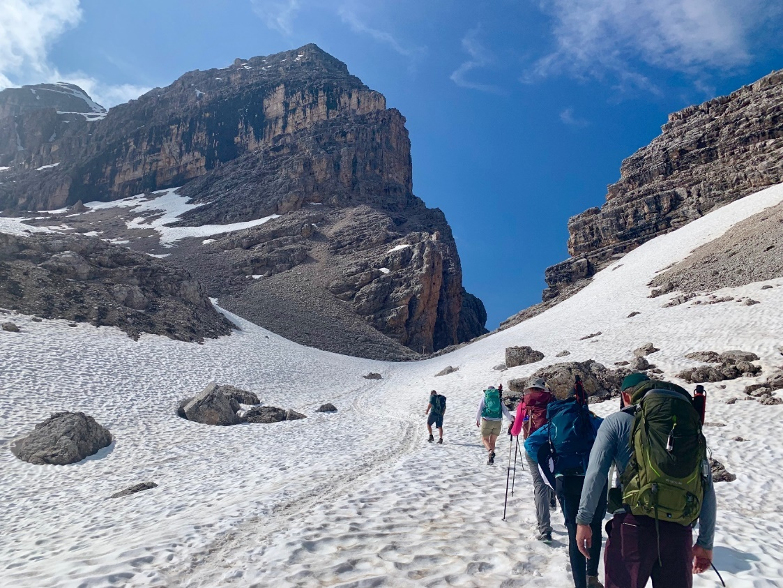
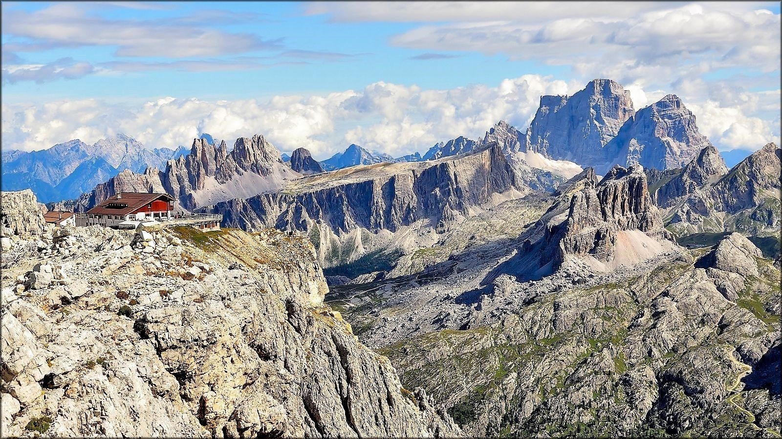
Refugio Lagazuoi
Day 6 – Wednesday June 21
From Rif. Lagazuoi we descend through the tunnels which were dug by the Italian army with the intent to blow up the summit of Lagazuoi. The Lagazuoi tunnel is steep and dark with many steps. We will need helmets (provided) and headlamps for the descent. There is an opt-out to bypass the tunnels and take the cable car to Passo Falzerego where you will meet the rest of the group.
From Passo Falzerego (2105 m) we have the option to walk or take the chairlift to Rif Scoiattoli (2255 m) to the Cinque Torri and continue to Passo Giau (2236 m). A shuttle will bring us to our Hotel in Cortina.

Walking time without cable car approx. 6 to 7 hours, ascent 1100 m (3608 ft), descent 1000 m (3281 ft), length approx. 12 km (7.5 miles)
Technical Route Category: (Some Moderate/ Mostly Easy) RBBBBB
Walking time with cable car approx. 3 to 4 hours, ascent 200 m descent 450 m, length approx. 6.5 km (4 miles)
Route category: (Easy) BBBBBB
Overnight at Il Tyrol Hotel, San Candido deluxe room with private bath
4 Star Hotel at San Candido - Sporthotel Tyrol
Meals: Breakfast and dinner

More About the Lagazuoi WWI Tunnels
https://www.lagazuoi.it/Eng/page7-Open-air-Museum-of-the-Lagazuoi

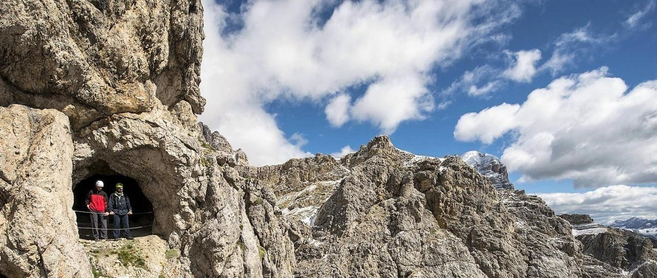
” Mount Lagazuoi is a veritable "castle of rock", with spires and turrets, and with military bases hidden in its bowels. During the Great War, the Italian and Austro – Hungarian armies dug shelters in its interior for men and arms, transforming it into an impenetrable 20th century fortress. Today visitors can hike the restored tunnels, trenches, and machine gun posts in the Open-Air Museum of Lagazuoi. The numerous routes lead hikers on a behind-the-scenes tour of a dramatic war fought at high altitude.
The entire area of the museum is crossed by paths doable on foot. Almost all the tunnels and trenches have been cleared and restored thanks to the work of numerous volunteers. Restoration of the steps has enabled easier access to the sloping stretches of the tunnels. It is possible to visit several different routes, some longer and more difficult, others shorter and easier.”

Inside the Lagazuoi Tunnel
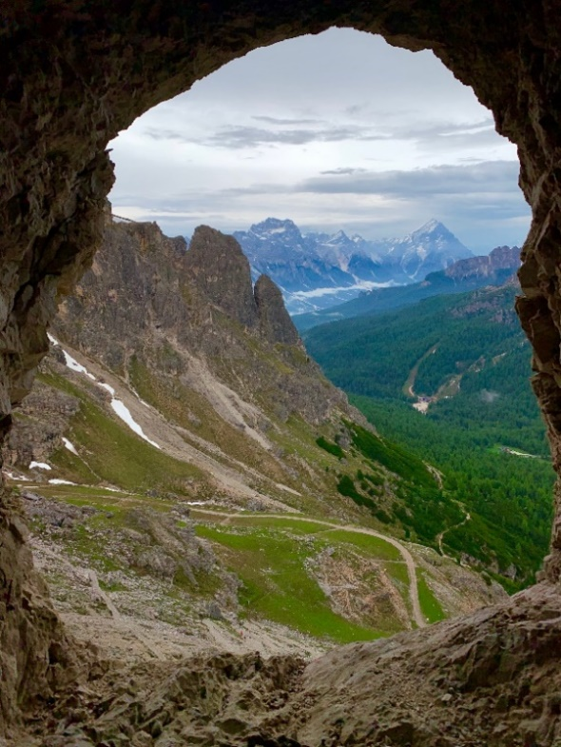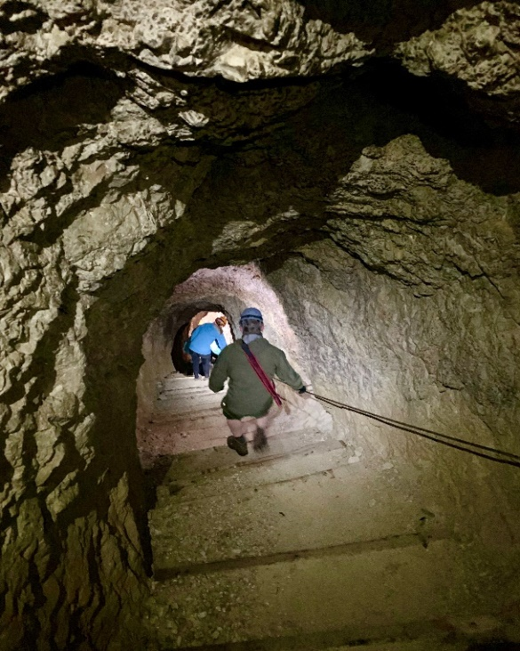
Day 7 – Thursday, June 22
From our hotel in San Candido we walk to the cable car for the ascent to the Haunold Hut; from there we hike up to Haunold Kopf and descend to Dreischusterhütte in the Innerfeld Tal. If the weather cooperates, we should be able to see the iconic Tre Cime for the first time. The hike to the Dreischusterhütte is probably one of the nicest hikes in the San Candido/Innichen region. Its main attraction is the wonderful peaks of the Sexten Dolomites that tower over the entire Innerfeldtal Valley. The area is also part of the incredibly beautiful and peaceful Drei Zinnen Nature Park. The destination for this hike is the Dreischusterhütte mountain hut. The hike is relatively easy with no particularly difficult sections.

Walking time approx. 5 to 6-hour, ascent 800 m (2625 ft), descent 650 m (2133 ft), length approx. 11 km (7 miles)
Possibility to skip the summit of Haunold Kopf - Walking time approx. 3 to 4-hour, 480 m (1575 ft) ascent, descent 330 m (1083 ft), length approx. 8 km (5 miles)
Technical Route Category: (Easy) - BBBBBB
Overnight at Dreischusterhütte – No luggage transport today, bring your overnight essentials in your day pack.
https://www.drei-zinnen.info/en/dobbiaco/action-sport/winter/alpine-ski/huts-rest-stops/15-drei-
schusterhuette-rif-tre-scarperi-hut.html
Private room with shared bath Meals: Breakfast and Dinner

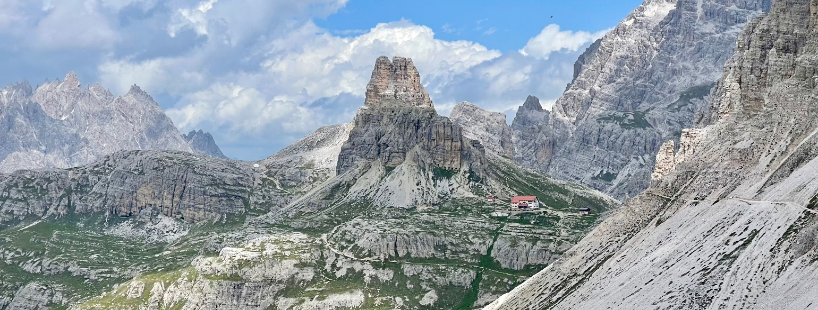

Drei Zinnen (Tre Cime) from the Trail
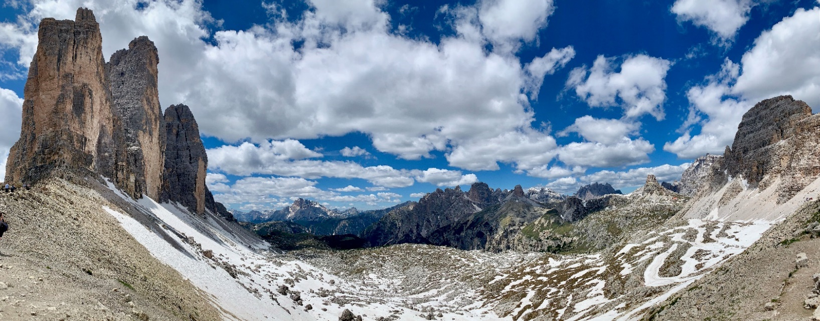

Day 8 – Friday, June 23
The last ascent leads us through the picturesque Innerfeldtal valley to the Drei Zinnen Hütte (2,438 m). From here the views are breathtaking all around and include the north walls of the famous Drei Zinnen (aka: Tre Cime). Breathtaking and spectacular are overused descriptors but there is no other way to describe this spot. The views before we reach the Hütte for lunch really cannot be described except to say they are spectacularly awesome. About one hour after lunch, we reach the Auronzo hut where there are more incredible views. A glass of wine while you sit, admire the view, and try to hold on to the last moments of this trek is a definite must do.
From here there is a short walk that you will want to do very slowly because when we reach the parking lot the transfer takes us back to our hotel in Cortina for the last night of our hiking adventure through the beautiful UNESCO Heritage Dolomites. You will not want to leave. In fact, you may start your own hiking company so you can do this hike every year.
Walking time approx. 4 hours, ascent 950 m (3117 ft), descent 250 m (820 ft), length approx. 10 km (6.2 miles)
Technical Route Category: (Easy) BBBBBB
Overnight at Il Tyrol Hotel, , San Candido deluxe room with private bath
4 Star Hotel at San Candido - Sporthotel Tyrol
Private room with private bath.
Meals: Breakfast and Dinner
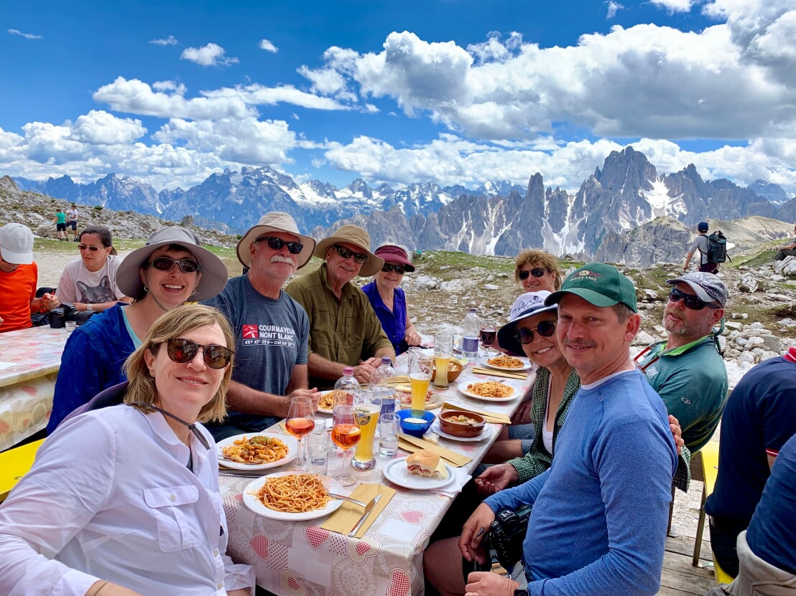
Al fresco dining does not get any better than this!
The views and the food are awesome.

Day 9 – Saturday, June 24
Enjoy breakfast then depart to continue travel at your own pace. Walk the World, LLC will arrange shuttle transportation back to Venice upon request.
Meals: Breakfast

Price: $3600 per person double occupancy, rooms will have either one double or queen bed, or two twin beds. We have private rooms throughout the trek and all, but the Lagazoui and Dreischuster huts, have private baths. In those huts the bathrooms are down the hall.

Included: Expert guide service, on-site trip organizer, daily luggage transfer, except where indicated, (duffel bag included) transportation from Venice or Bolzano to Lago di Braies, two nights in a lodge, two nights in hotels and four nights in refugios, rental gear (ice spikes and helmets), chairlifts to the Cinque Torri and Haunold, cable car backpack transport to Passo Falzarego, eight breakfasts, and eight dinners, including a farewell dinner on the last evening. Training tips, packing, and gear guides.

Not included: Lunches on the trail, extra food and snacks during the day, drinks, airfare, special transportation (apart from the included group transportation), departure from Cortina, and special transportation during the hike if needed or wanted.

Our Dolomites Guide
Mathias Klebaur

»The mountains are balm for the soul«
Mathias (Thia) has been guiding hikers on some of the most beautiful and challenging trails in Europe for over 25 years. He is a Certified Mountain and Ski Guide with an additional qualification as a canyoning guide, a member of the Mountain Rescue Hindelang, and a Region Instructor for Bergwacht Allgäu, the Mountain Rescue Service for the Allgäu region in the Bavarian Alps. Thia splits his time between his homes in Bad Hindelang, Germany and Revelstoke, British Columbia, Canada where he is a heli-ski guide during the winter season for Canadian Mountain Holidays.

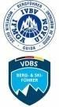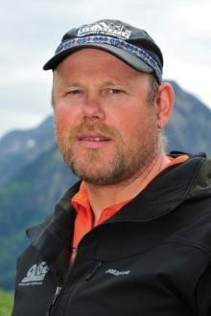

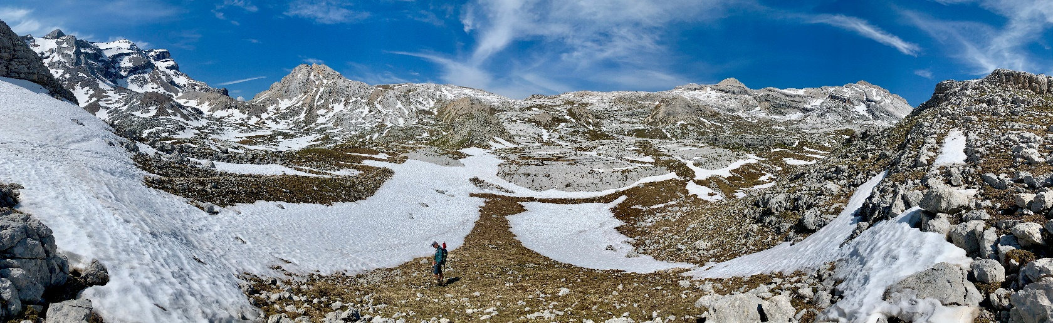

Requirements:
Good physical condition, mountain experience, above average fitness (must be able to hike, surefootedness and endurance for daily stages up to 7 hours). There could still be patches of old snow on some spots which will require snow spikes. There may be changes to the planned route due to weather such as snowfall, lightning, or other hazards. Our guide will determine if conditions are safe for the group.

Required Gear:
Hiking boots (no trail shoes), rain jacket, rain pants, headlamp, gloves or thick glove liners, hat (for sun and rain). Notice: If you do not have hiking boots in good condition you will either need to purchase them in Italy before you start the hike, or you will not be able to participate. If you do not have a headlamp, you will not be able to descend the Lagazoui tunnel.

A Note About the Dolomites Trek Rating System
Europeans use a different rating system than in the US and because the guide is from Germany, I am using the rating descriptions they would use. The Technical Route Categories used for each hike, which have been simplified from a more detailed scale, are combinations of the letters “B” and “R” and indicate the level of technical difficulty not the vertical ascent or miles hiked each day. A hike could be 8-10 miles and 3500 feet of elevation but if it didn’t involve cables, ladders, cliffs or rock climbing it would be considered “Easy”, whereas a hike with that distance and vertical ascent would be rated difficult in the US.
In the US there is a route classification system, known as the Yosemite Decimal System (YDS), but generally, hikers aren’t aware of it because it is a scale used mostly by climbers. Guidebooks and apps like AllTrails would not include hikes with a Route Classification of 3 or above. Not true for Germany. The hike or trek would be rated moderate or difficult depending on technical skills required. Only very experienced climbers would attempt a “Difficult” trek, it would not be suitable for hikers no matter the level of physical conditioning.
The Dolomites trek, by US standards, would be considered moderately strenuous to strenuous based on similar hikes I have done in Yosemite and Colorado that were rated as such. For example, Grays and Torrey’s Peak in CO (7.8 and 3582ft), Four Mile Trail in Yosemite (7.5 miles and 3277 ft), and Mountain Dana Peak on the Eastern side of Yosemite which starts at 9700 feet and goes to 13,250 feet (7.0 miles and 3103 ft, classed at 1 -2 by YDS) are rated as “Difficult” on AllTrails and would be considered “Easy” by German standards because there are no cables, ladders, or narrow trails with steep drop offs. The Dolomites Trek would be rated Class 2 on the YDS scale.
For more information on the YDS system go to: https://www.rei.com/learn/expert-advice/climbing-bouldering-rating.html

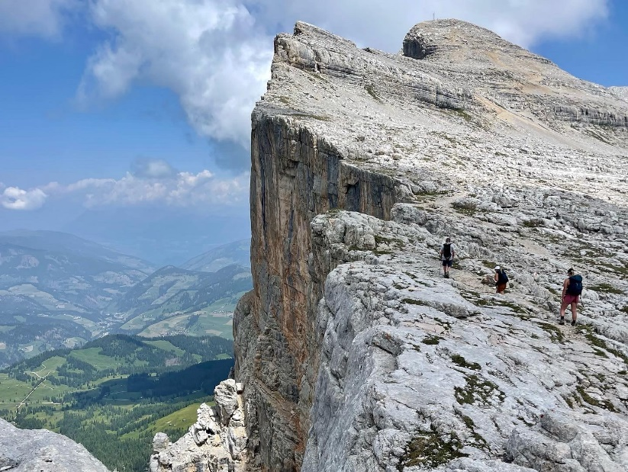
Route Difficulty
B= Simple Mountain Paths -- Simple mountain trails are mostly narrow, can be steep and have no crash prone passages (meaning that the trails may be single track but do not involve cliffs, see sample pictures below).
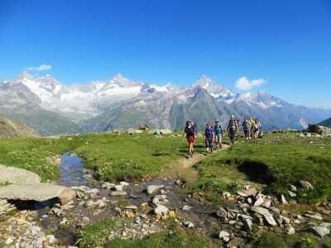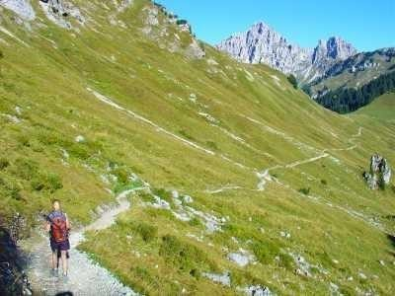

R = Moderate Difficulty Mountain Paths -- Medium-heavy mountain trails are mostly narrow, often steep and can have crash-prone passages. There may also be brief technical walking passages (e.g. cables or ladders). It is possible to opt out of these days and in some cases just those portions of the hike which are rated moderately difficulty.
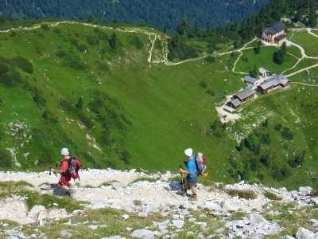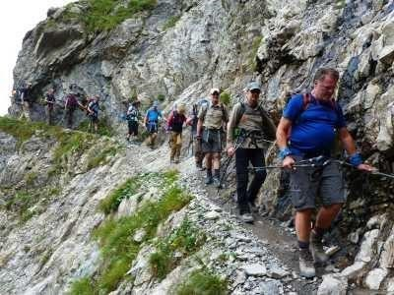

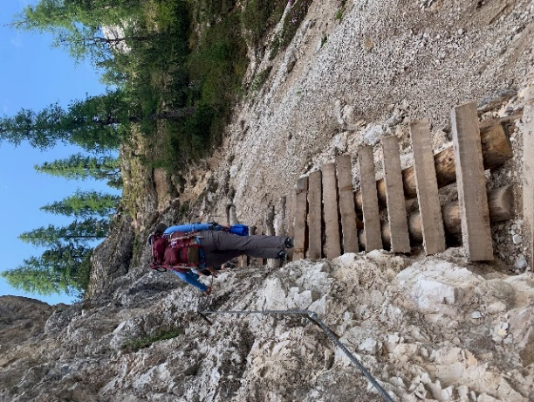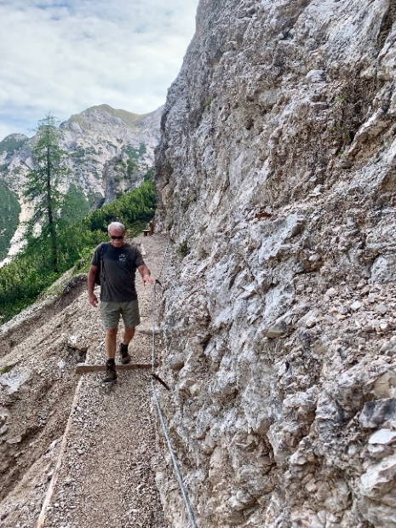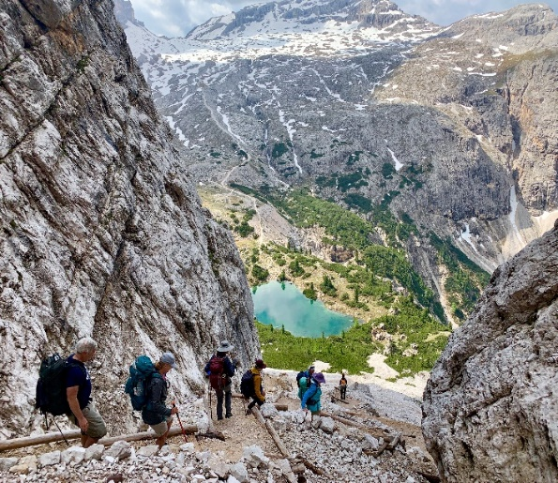
Route Difficulty does not consider distance or vertical ascent. Route Difficulty refers only to the technical aspects of the trail such as whether cables, ladders, or steep drop-offs are included.

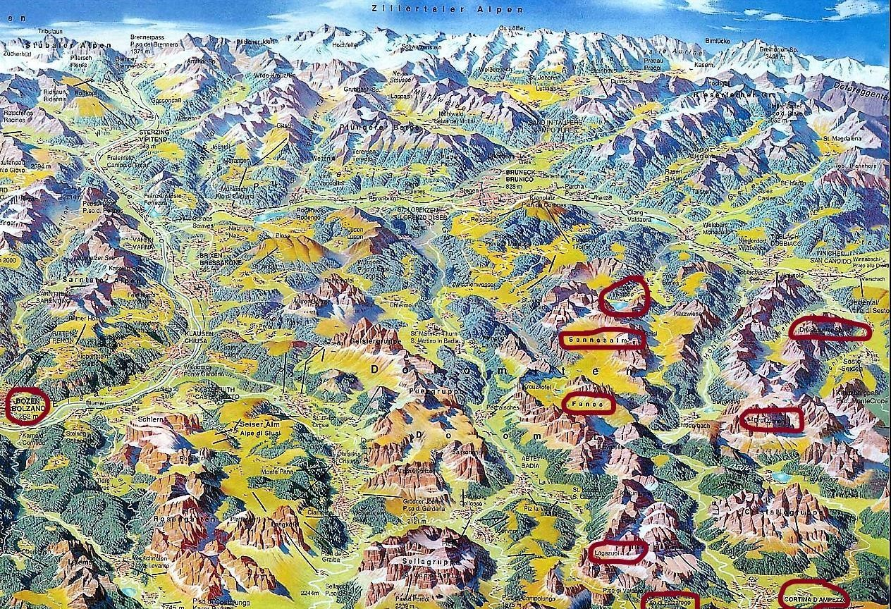
This map shows some of the specific areas we will hike to circled in red. Cortina, where we spend our last night, is in the lower right corner. If you look closely, you can see the Fanes Plateau, Lagazuoi, and Dreischuster where our hut stays are planned. The views from the huts are spectacular! After completing this hike in 2019, I am convinced it is the most unique and spectacular place I have hiked.

Photos which are courtesy of Robert Schmalle Photography are copyright protected and may not be printed, copied, or used without permission of Robert Schmalle Photography. The photo of the Lagazuoi hut is copyright protected as well. The remaining photos were taken on the hike during June of 2019 and should not be used for commercial purposes.

